Cystic fibrosis

Main causes

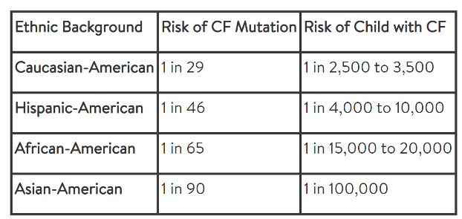Cystic fibrosis (CF) is a life-threatening disorder that damages the lungs and digestive system. It is a genetic disease which means that it is inherited. A child will only be born with a CF gene only if they inherited one CF gene from each parent and if a person only has one CF gene, they are called a carrier. When a couple has had a child with CF there is a 1 in 4 chance that every additional child will be born with CF. This means that there is a 3 out 4 chance that the additional children will not have CF, but still might be carriers of the CF gene. Genes are found in structures called chromosomes. The 7th pair of Chromosomes have a gene called CFTR or cystic fibrosis transmembrane conductance regulator gene. This specific gene controls the flow of salt and fluids in and out of the cells. A mutation of the gene is what cause CF. More than 18,000 different mutations in the CFTR gene have been found that cause CF. According to CF foundation if there is not any family of CF then the risk of having a mutation in the gene depends on your ethnic background.

Symptoms and diagnoses

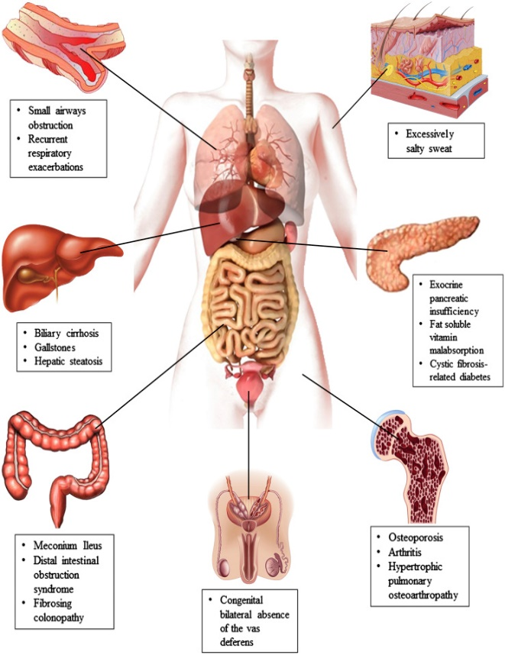The symptoms of CF can vary depending on the person and the severity of the condition and the age at which the symptoms develop can also differ. Symptoms might appear early in infancy, but for other people the symptoms might not appear until after puberty or even later in life. As the person gets older the symptoms related to the disease may get better or worsen. One of the first symptoms that can be recognised is a strong salty taste of the skin, parents with children who have CF have mentioned tasting the saltiness of their children’s skin when kissing them. The symptoms occur from complications of the lungs, pancreas, live and other glandular organs. The thick and sticky mucus associated with CF blocks the passageways that carry oxygen in and carbon dioxide out of our lungs, this may cause the following symptoms a stuffy nose, reoccurring lung infection, a cough that produces thick mucus or phlegm, shortness of breath, wheezing and stuffy sinuses. The mucus in the abdominal can also clog up the channels that carry enzymes produced by the pancreas to the small intestine. Since the intestine is not getting the enzymes needed it cannot absorb the necessary nutrients from the food, this can cause these symptoms such as, nausea, greasy foul-smelling stools, constipation, loss of appetite, a swollen abdominal, poor weight gain in children and delayed growth. The main test to diagnose patients is the sweat chloride test. This test helps diagnose CF by measuring the concentration of salt in a person’s sweat. This test is performed by using a chemical which makes the skin sweat, the sweat is collected on a pad or paper and then analysed. This painless test is the most reliable way to test if someone has CF. Other test also used to diagnose CF are the following, immunoreactive trypsinogen test, sputum test, chest x-ray, CT scan, and pulmonary function test.

Current treatments and how they work.

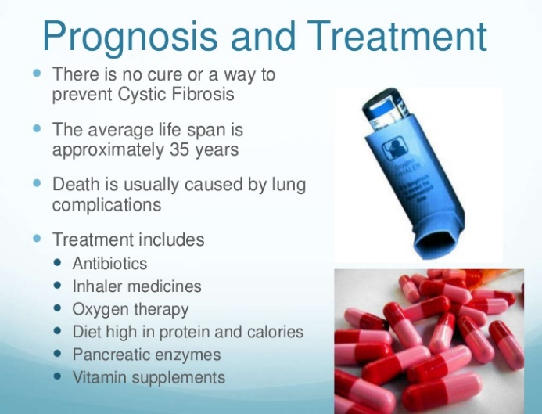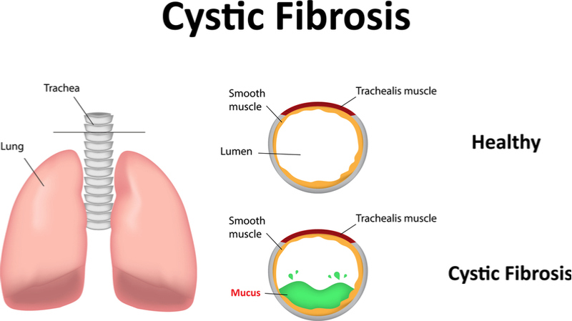There is no cure for CF but there are treatments that help ease the symptoms, reduce complications and help improve quality of life. People with CF are treated by a group of health care professionals. The medication used to help treat CF may vary depending on the person and the severity of their symptoms. Treatments may include, medications, exercise, nutritional and respiratory therapies. There are many medications that help with CF such as antibiotic to help get rid of lung infections, mucus thinning medication, helps make the mucus thinner and less sticky. It also helps for the patient to cough up the mucus so that it leaves the lungs. Bronchodilators, it helps to relax the muscles around the tubes that help carry air into the lungs. This helps increase the air flow and is taken through an inhaler or a nebulizer. Anti-inflammatory drugs help to reduce the inflammation around the air way and helps to prevent it. CFTR modulators are a class of drug that help by improving the defective CFTR gene. They work by targeting the defective proteins and work to control their effects by moving them to the cell surface and helping them function properly. Chest therapy helps by loosen the mucus in the lungs which makes it easier to cough it up. The common technique used involves placing the patients head over the edge of a bed and clapping with cupped hands over the sides of their chest, there is also a mechanical device that does this. There is also an inflatable vest which vibrates at a high frequency to help remove chest mucus. Home care to help treat CF are drinking lots of fluids because it helps to thin the mucus in the lungs and try to avoid pollen, smoke and mould if possible, theses things can make symptoms worse. Exercise on a regular basis to help thin the mucus in the lungs and get an influencer and pneumonia vaccinations regularly.

Prevention

CF cannot be prevented because it is a genetic disease, although testing for CF should be done for couples who have it or have a family history of it.

Pneumonia

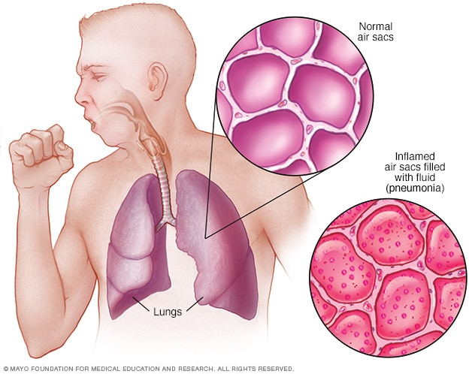Main Causes

Pneumonia is an infection which inflames the alveoli in one or both lungs. The alveoli may fill with pus or fluids causing a cough with pus or phlegm, which makes it hard to breath. You can get pneumonia from bacteria; this type of pneumonia can occur on its own after you have had a cold or flu and may only affect one part of the lung called lobar pneumonia. Mycoplasma can also cause pneumonia; it usually produces mild symptoms when compared to the other pneumonias. Fungi can also cause pneumonia; this pneumonia is most common in people with a weaker immune system or other chronic health problems. It is caused by inhaling large amounts of organisms; there fungi can be found in bird poop, on plants and in soil and can also vary depending on your location. Aspiration pneumonia only occurs when a person inhales drink, food, saliva and vomit into your lungs. This from of pneumonia is most common to occur in a person if something disturbs their normal reflex. Such as if a person has been using an excessive amount of alcohol, drugs, a brain injury and or a swallowing problem. The germs that cause pneumonia are also contagious meaning they can spread from person to person although you cannot contract fungal pneumonia from a person. Both viral and bacterial pneumonia can be spread from person to person through inhalation of airborne droplets from a sneeze or cough.

Symptoms and diagnoses

The symptoms of pneumonia can vary from mild to life threatening depending on the person and depending on the type of germ that is causing the infection. The mild symptoms usually have the same of a common flu or cold but last longer. The signs and symptoms of pneumonia are the following a cough which might produce phlegm, confusion or changes in mental awareness (In adults aged 65 and older), chest pain when you sneeze or cough, fatigue, lower than normal body temperature; mainly happens in in adults 65 or older a people with a weak immune system, shortness of breath, nausea, vomiting or diarrhea, fever, sweating and shaking chills. A chest x-ray is the most common way to diagnose pneumonia. Other tests to diagnose pneumonia are the following, a blood test which confirms an Infection, sputum culture is when a sample of the patient’s mucus is collected after a deep cough, it is them analysed to find the cause of the infection. Pulse oximetry, it measures the amount of oxygen in a patient blood. This helps to see whether your lungs are moving enough oxygen through the bloodstream. A CT scan, this provides a clearer and more detailed picture of the lungs. Fluid sample is taken from the chest to help identify the reason of the infection and a Bronchoscopy; it investigates the airway in the patient’s lungs.

Current treatments

A doctor may prescribe some of the following medications to help treat pneumonia. Antibiotics for bacterial pneumonia, antiviral medicine and antifungal medicine. Theses medicines all help to kill certain bacteria that can be found on the lungs when a person has pneumonia. If a patient has a more serious case of pneumonia your health care team may need to perform procedures or surgeries to remove an infected or damaged part of the lungs. A patient may also need to get antibiotics and fluids through an intravenous line inserted into your vein. Lastly you may need oxygen therapy to increase the amount of oxygen in your blood and may need a ventilator to help with breathing.

Preventions

You can get a shot to help prevent and lower the risks of getting bacterial pneumonia. You can also help prevent pneumonia by doing these things, eating right healthy food with plenty of fruits and vegetables, get regular exercise, make sure your getting enough sleep, quite smoking, wash hands regularly and especially after using the bathroom and before eating and try to stay away from sick people.

References

<https://www.healthline.com/health/pneumonia#is-it-contagious>

<https://www.mayoclinic.org/diseases-conditions/pneumonia/symptoms-causes/syc-20354204>

<https://www.healthline.com/health/pneumonia#is-it-contagious>

<https://www.nhlbi.nih.gov/health-topics/pneumonia#:~:text=A%20chest%20X%2Dray%20is,enough%20oxygen%20into%20your%20blood>.

<https://www.cff.org/Life-With-CF/Treatments-and-Therapies/Medications/Antibiotics/>